Utah

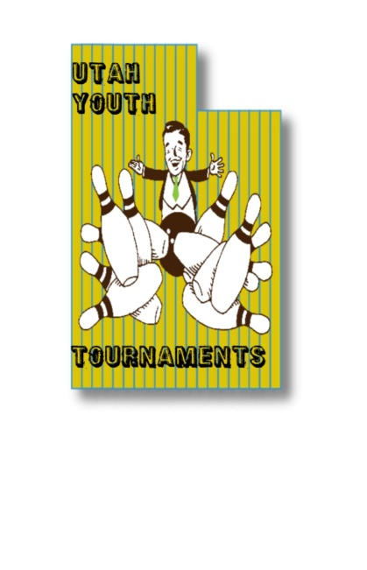Youth Open

$400 Guaranteed to each winner

June 10th, 11th, 12th

Delton Lanes, Bonwood Bowl, Valley Lanes

Start time is 6:30pm at Delton Lanes

**Entry Forms must be received by June 1st 2022. Tournament is limited to the first 80 entries.**

Mail entry forms to the tournament director or register online

Facebook.com/utahyouthbowling

www.utahyouthbowling.com

Tournament Director: Steven Vanderbloom (Cell) 435-841-7862

E-mail: utahyouthtournaments@gmail.com

Address: 118 Tram Rock Rd., Lake Point, UT 84074

Name____________________________________________ Sex_______ USBC #___________________________

Address______________________________ City_________________________ ST_____ Zip_____________

Date of Birth___________________ Junior Gold **YES NO**

Phone_________________ Amount enclosed _______ E-Mail_________________________________________

**Utah Youth Open (07791)**

**ELIGIBILITY:** Open to all USBC Youth members with a valid membership in good standing

**DIVISIONS and FORMAT:** This is a scratch tournament. All bowlers will bowl 3 games at each center on day 1 and day 2 (9 games total). Day 3 will be match play and stepladder finals to determine division winners. The divisions will be boys U18, U15, U12 and girls U18, U15, U12.

The top 8 in the U18 and U15 divisions after day 2 will enter in to match play. Each bowler will bowl 4 games in their division. The top 4 in the U18 and U15 divisions will then face off in a stepladder finals based off of match play record.

The top 6 in the U12 divisions after day 2 will enter in to match play and will bowl 3 games. The top 3 in the U12 divisions will then face off in a stepladder finals based off of match play record.

If there is a tie in number of wins, match play scratch totals will then be used to break ties.

**ENTRY FEES:** Fee per Person - $60 Breakdown – Scholarship/prize fund $12.00, Lineage $43.50, Expense $4.50. 100% of prize/scholarship fund will be awarded. No Refunds – USBC Rule 314. Junior Gold entry fee is U18 $40, U15 $30, U12 $25.

**BOWLER’S AREA:** Only participants & tournament officials are permitted in the bowling area. Food & drink will be permitted during competition outside of the bowler’s area.

**DRESS CODE:** All participants may wear casual slacks, trousers, jeans, skorts and shorts. All participants are required to wear a shirt with sleeves. Collared or Mock Collared shirts are preferred. Unacceptable attire includes, but not limited to: Tank tops, bare midriffs, workout attire, lounge pants, bib overalls, jeans that are torn, hats or attire with inappropriate, or offensive language or graphics. The tournament management will have final decision on all dress code related issues and reserves the right to require any participant to change any article of clothing determined not appropriate for tournament participation. If bowler refuses to change once requested, bowler will be disqualified and forfeit entry fee for the event of occurrence.

**SCHOLARSHIPS AWARDS:** Scholarship Prize Fund will be paid out to those who make match play.

**Junior Gold Qualifier** – This event will be a Junior Gold Qualifier. Bowlers will use their first 3 games for qualification in their age division. Tournament organizer has the right to combine divisions if needed. U18 and U15 will advance at a 1 to 5 ratio and U12 will use a 1 to 4 ratio. In case of a tie there will be a 10th frame roll off. If the score is still tied, bowlers will bowl one shot at a time until the tie is broken with the highest pin count advancing.

All rules for the 2021/2022 Utah Youth Open are subject to change due to concerns with COVID-19. This includes, but is not limited to, tournament dates, locations, format(s), operations and bowler services.

Any disputes must be brought to the tournament officials on site at the time of occurrence and will be settled at that time. All protests and appeals must be in accordance with USBC Rule 329. Anything not covered within the tournament rules will be governed by tournament management and USBC national playing rules.

Entries must be submitted no later than May 31st 2022.

Lane oil patterns will be Del Ballard, Carmen Salvino, Mark Roth, and PBA Tournament of Champions. Oil patterns are not listed in order.